Candidate User Guide
Apple Mac

Prior to your exam, please go to the following link and download the EDExams Application.

https://edexams.com/candidate-software.html

Please click the CLICK HERE TO DOWNLOAD APP button.



The file should then begin to download.

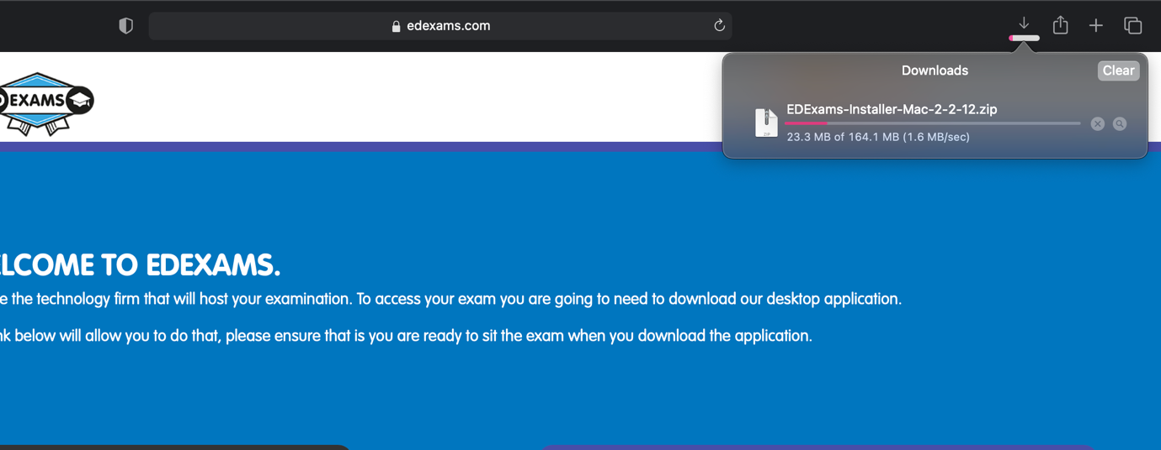

Once the file has finished downloading, double click the file to open it. Once it has open, the window shown below should appear. Please drag the EDExams Icon into the Applications folder.

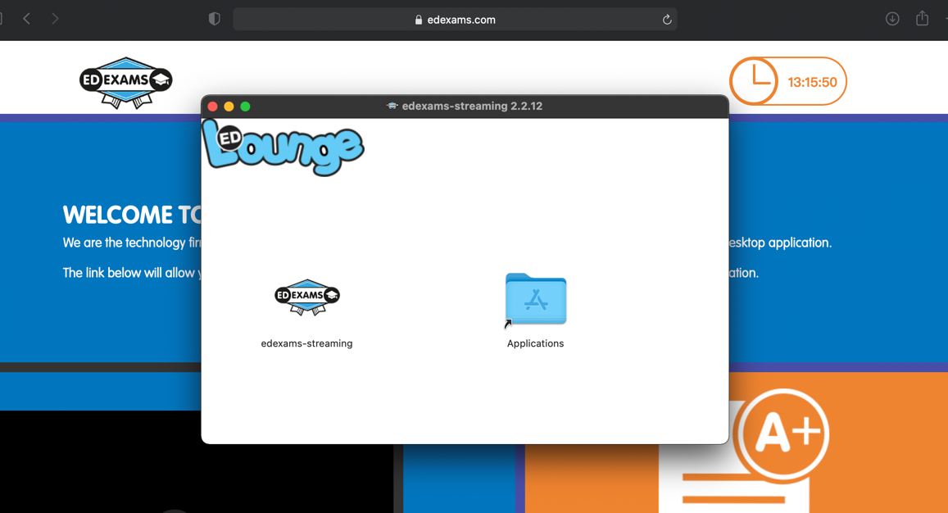

Once you have moved the icon into the folder, please close the window. Then open the finder on your mac, the icon should look like the image below.



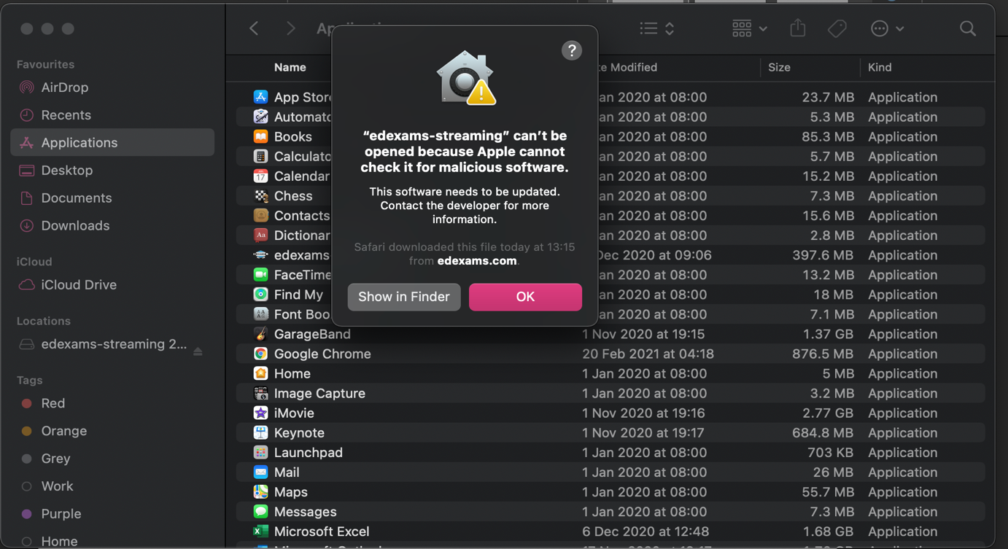
Then go into your applications. Right click on the EDExams App and select open. The following message should appear. Please select okay and the message should disappear.
Then right click the EDExams App and press open again. The following message should appear. Please select open.

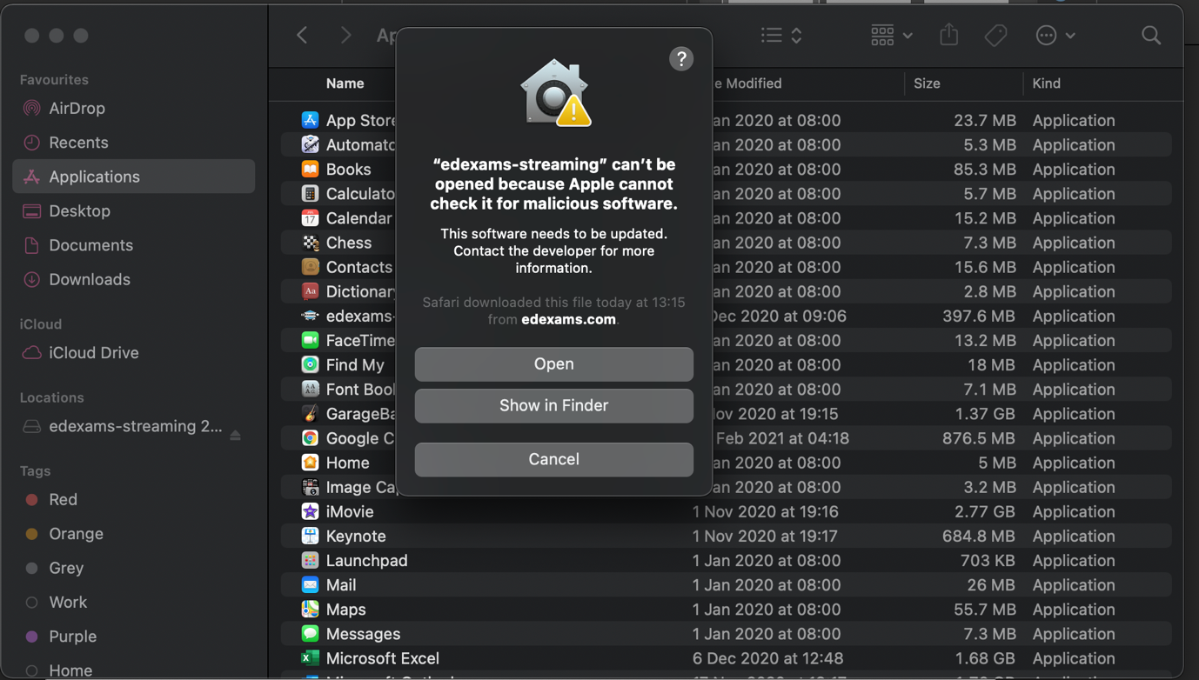

Once you are at the EDExams Log in page, please select Check status and follow the steps to check your microphone/webcam are working.

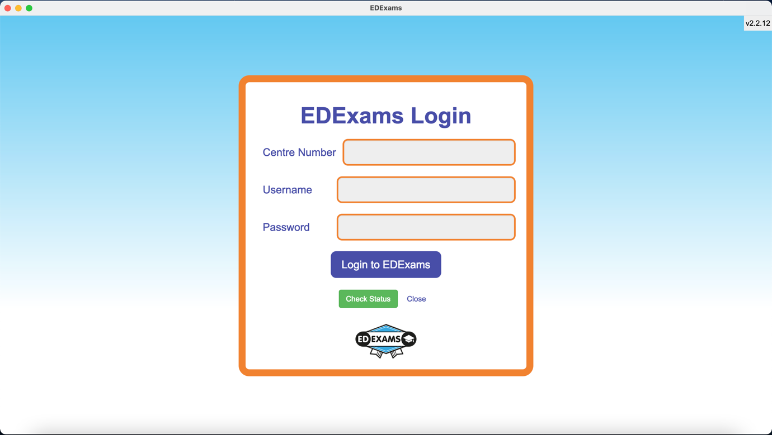

To ensure that the EDExams app has permission to use your webcam/microphone and to screen record, please open your computer settings. Then select Security and Privacy.

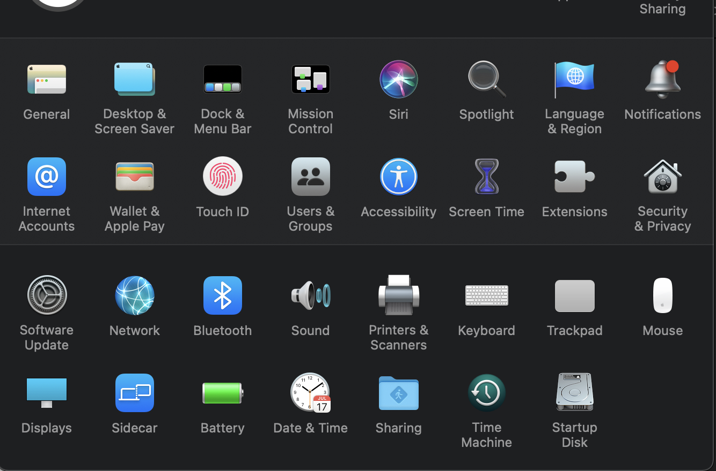

Then select Privacy. Please ensure that the edexams-streaming box is ticked in camera, screen recording and microphone sections located on the left hand side. If you cannot tick the box, click the padlock in the bottom left-hand corner and enter your password. Once you have ticked all three boxes, click the padlock again to save changes made.

